Agenda

*Date: 11/16/13*

*Location: Brody Collaborative Space - Room 1045*

*Actual Time: 1 pm - sometime*

*Planned Length: a while*

***Silly Picture of the Week:***

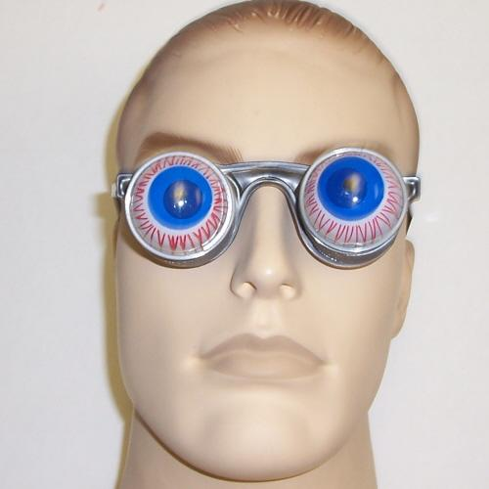

***Please add and comment on anything and everything in the agenda!***

|  |  |  |  |
| --- | --- | --- | --- |
| **Team Member(s)** | **Topic** | **Time** | **Goals** |
| ~~Anyone~~ | ~~Announcements~~ | ~~5 min~~ | ~~If any new developments have occurred the team is updated on them~~ |
| ~~Shannon~~ | ~~Team Bonding Update~~ | ~~8 min~~ | ~~Archery’s out. What shall we due. Pizza party? Interpretive dance competition?~~ |
| Andrew N. | Hardware | 20 min | Brainstorm design ideas to try to agree on a working design idea, document it; Take red eye photos (or attempt to); get eye-fi workinng (and make dvs email for it); DOCUMENNNNNT |
| Front End | Continue rewriting | A long time | Make new panels and things! And document the heck out of everything. |
| David and Arvind | Strabismus Detection |  | Draft algorithmic idea of what to do. |
| JT and Brian | Rewrite pupil detection | A lot of time | Make it workz. |
| Shannon | Code Integration | 40 min | Integrate white dot detection and crescent detection |
| Mark | Fix Pupil Manual Reset | 20 min | Figure out what’s going wrong when pupils are reset and fix it. |
| Shannon | Recap and Next steps | 5 min. | Meeting progress/ goal accomplishment is recapped. Next steps are outlined so that every team member goes into next week knowing what they are expected to contribute |

# Notes

Dropbox: <https://www.dropbox.com/sh/8nsmamaiklpvr9l/Fo5xgv4ogH>

# Summary

Team Bonding - Sushi?

RB sushi

# TODO

# Whiteboard Pics

# 

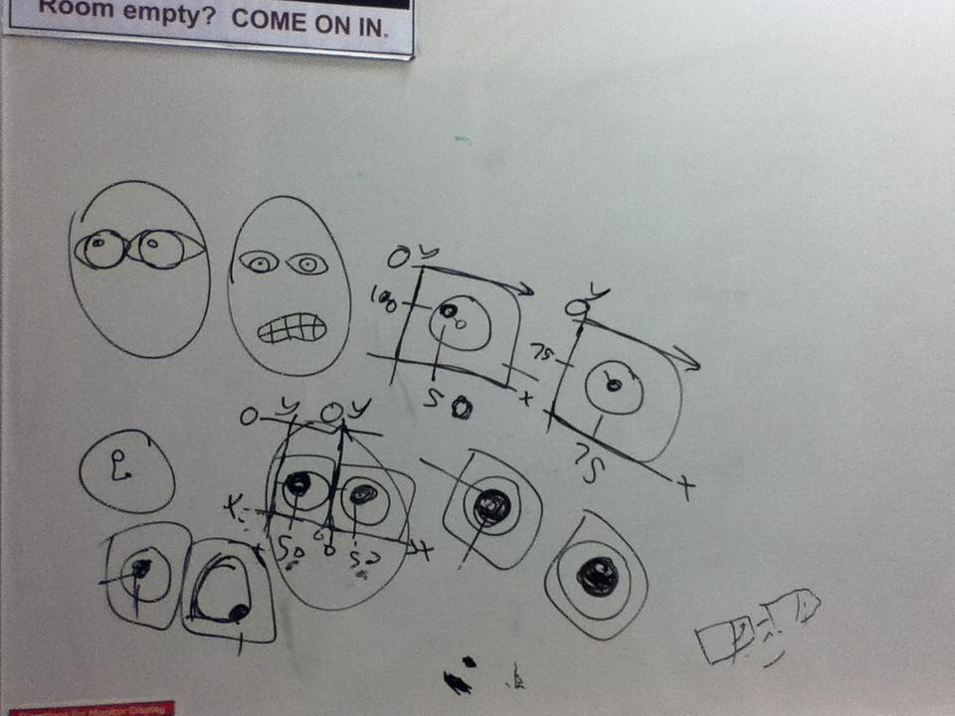

# Useful Links